# Using the library to generate the html reports

1. Add the attribute “ReportDisplay” for your properties in the class. Mention the text to be displayed in the report against the property.

NOTE:

***Only the properties with this attribute will be displayed in the report.***

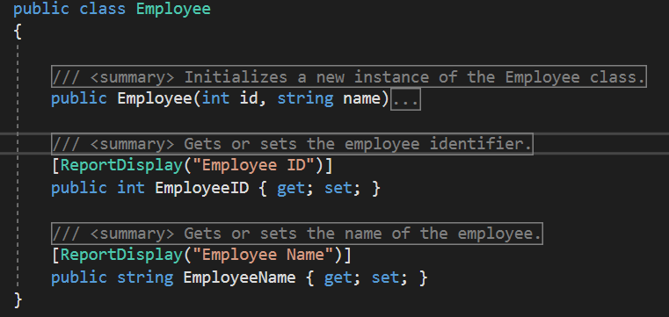

1. Form the collection of object that need to be displayed in the report

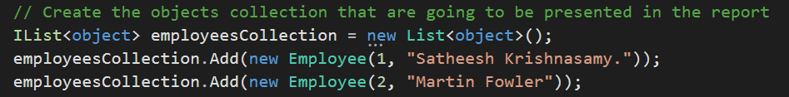

1. Create the report part object by calling IR*eportBuilder.AppendReportSection* method. Mention the type of display for the report content/section/part. Currently there are 3 types (Table, label and paragraph). Choose the one you wish. Mention the title and subtitle of the section

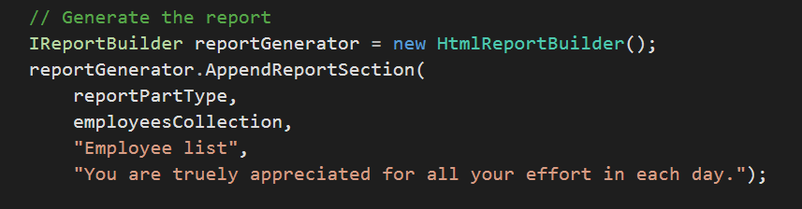

1. Create the html report generator class instance. Generate the report (string) using the report generator.

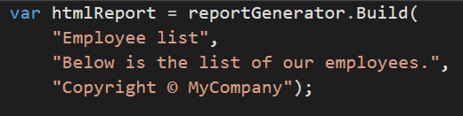

Save the string in a file with the name and location you want. Your report is ready.

NOTE: Please ensure that the properties “Build and Copy To Output Directory” of the template file “HtmlReport.xslt” to the values as shown below.

